Najee Walls

CS 218

Final Project Proposal

“Lemonade Stand”

I’m basing this program on an old online game called “lemonade stand”. The program will ask the user for Inventory of Paper Cups, Lemons, Cups of sugar, and Ice cubes. The button will calculate expenses for all 4 products.

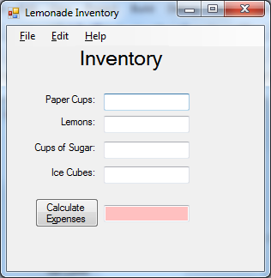

After this a 2nd form will show carrying the values set by the 1st form. This will ask the user for the number of lemons and cups of sugar per pitcher, and the number of ice cubes per cup. Since more ice in a cup means there is less room for the lemonade, the more ice there is in a cup, the more cups of lemonade there can be served in a pitcher. Once it is determined how many cups of lemonade there can be made per pitcher, the program will find out how many cups can be made before running out of ether cups, sugar, or lemons. After that number is determined, it is multiplied by the price per cup for revenues. Revenue is subtracted from expenses of the inventory for the profit.

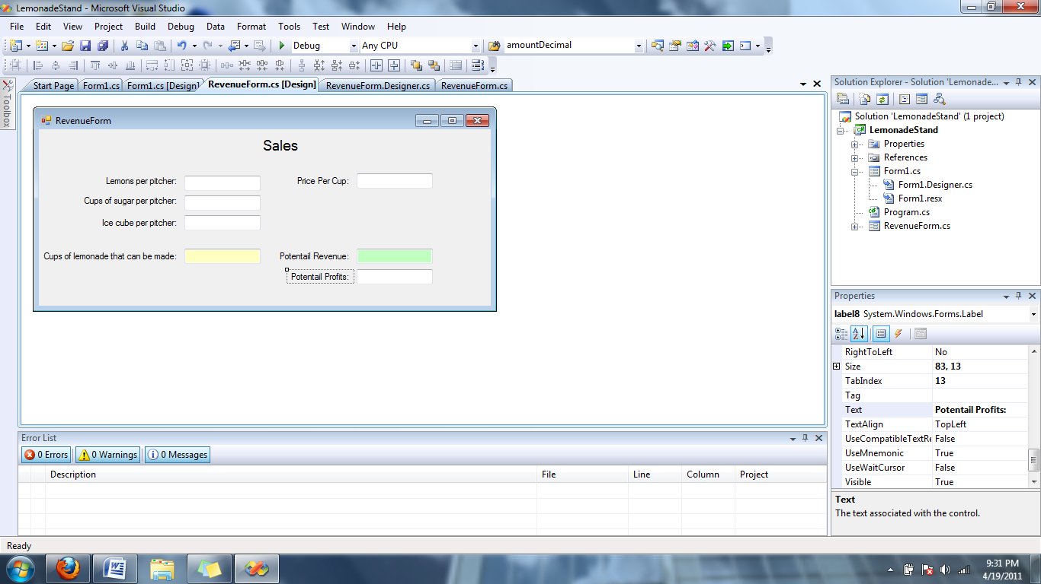

Splash Screen

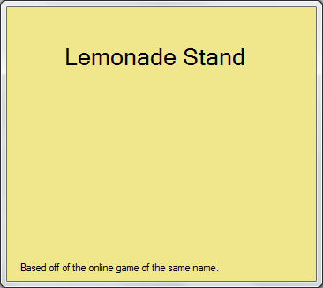

About Screen

